A140 User Guide

511-846-00-04

Please follow the instructions in this installation guide carefully in order to quickly and safely start enjoying the benefits of digital TV. We advise carefully reading all of the enclosed safety and installation instructions before using the product.
Please keep this installation guide for future reference.
Your service provider will give you a separate User Guide that will explain how to access the services and features that are available through your digital TV service.

Software Updates
This product is designed to evolve and as a consequence, it benefits from software updates provided and installed
automatically by your service provider. Amino Communications Ltd. and your Service Provider reserve the right to automatically update the software on the product in order to improve the product functionality.

During software updates, the Amino A140 cannot be used and

The first time it is powered, it is possible that the Amino A140 will immediately start updating itself with the latest operating software. While the software is updating it is important that

complete after a few minutes and you will then be ready to enjoy the full benefits of your new digital TV service.

Product Safety

Warnings, Cautions and Notes
Throughout this manual, please pay special attention to the following indications of potentially hazardous situations:

Warning!
Indicates a hazardous situation, which, if not avoided, could result in serious injury.

Caution!
Indicates a situation, which, if not avoided, could damage the product or other devices.

Note!
Indicates additional information to the user to make the user aware of possible problems and to help the user understand, use and maintain the product.
Warnings, cautions and notes are included in the product literature to ensure your safety and the correct operation of the product – please adhere to them.

Attachments
Use only the supplied accessories and attachments with this product. Use of accessories or attachments that are not supplied or approved by the manufacturer may be unsafe, may be detrimental to the life or performance of the Amino A140 and will immediately invalidate any product warranty.

Water and Moisture
To reduce the risk of fire or electric shock, this product, its accessories and attachments must not be exposed to any liquids, rain or moisture. The product must not be exposed to dripping, splashing or high humidity. Do not use this product in any location where it may become in contact with any liquid or vapour.

Product Care

Servicing
This product contains no user serviceable parts.
The product must not be dismantled. Attempts to dismantle the product may be unsafe, may be detrimental to the life or performance of the product and will immediately invalidate any product warranty.

Servicing must only be attempted by suitably qualified service personnel.

Cleaning
Do not spray any substance or use any polishes, thinners, abrasive cleaning products, liquids or aerosol products to clean the product, its accessories or attachments.

Important Safety Instructions

Installation

Read these instructions. Keep these instructions. Heed all warnings.
Follow all instructions. Clean only with a dry cloth.

- Once removed from the transit packaging, the apparatus must be handled with care and must not be dropped, shaken or exposed to any physical shock.

- Disconnect the apparatus from the mains before you start any installation procedures.
- The apparatus is designed to be placed horizontally on a hard flat surface.

- Do not place the apparatus where it may be subject to physical shock or vibration or where the product may drop, topple, slide or shake as this may cause personal injury or irreparable damage to the product, which will not be covered by the manufacturer’s warranty.

- Do not stand the apparatus on a soft surface such as carpets or soft furnishings etc as these surfaces will obstruct airflow, may cause the product to overheat and will invalidate the warranty.

- Do not block any ventilation openings. Install in accordance with the manufacturer’s instructions.

- Do not install the apparatus into any built-in installation such as bookcase or rack without ensuring that a minimum of 100mm (4”) of clear space is available at the front, rear, sides and top of the product.
- Do not install the apparatus near any heat sources such as radiators, heat registers, stoves, or other apparatus (including amplifiers) that produce heat, or where it may be exposed to direct sunlight.

- Do not cover the apparatus.

- Do not stack electronic equipment on the top of the apparatus or place on top of any surface that may become warm in use (such as an AV amplifier)

- “WARNING” - “To reduce the risk of fire or electric shock, do not expose this apparatus to rain or moisture”.

- Do not use this apparatus near water.

- Do not expose the apparatus to dripping or splashing; no objects filled with liquids such as vases should be placed on the apparatus.

- Do not pick or move the apparatus whilst it is operating. If the product must be moved, please unplug the lead from the wall socket and wait 30 seconds before moving the product.

- The apparatus is not suitable for outdoor use. The leads and power-supply cord must be routed where they cannot be walked on, chafed, tripped over or pinched by items being placed
on or against them. Power-supply cords must not be routed underneath carpets or rugs where any damage could not be seen.

- Protect the power cord from being walked on or pinched particularly at plugs, convenience receptacles, and the point where they exit from the apparatus.

- Operate the apparatus only from the type of power supply supplied by the manufacturer and as indicated on the marking label. The mains lead is fitted with a plug that is designed for use with the power source of the country of installation. If you are not sure of the power supplied to your home, consult your local power company.

- The socket-outlet shall be installed near the equipment and shall be easily accessible.
- Do not defeat the safety purpose of the polarized or grounding- type plug. A polarized plug has two blades with one wider than the other. A grounding type plug has two blades and a third grounding prong. The wide blade or the third prong are provided for your safety. If the provided plug does not fit into your outlet, consult an electrician for replacement of the obsolete outlet.

- Only use attachments and accessories specified by the manufacturer.

- Refer all servicing to qualified service personnel. Servicing is required when the apparatus has been damaged in any way, such as power- supply cord or plug is damaged, liquid has been spilled or objects have fallen into the apparatus, the apparatus has been exposed to rain or moisture, does not operate normally, or has been dropped.

- No Naked flame sources, such as light candles, should be placed on the apparatus.

- Disconnect the apparatus from the wall outlet before cleaning.

Operation
The apparatus and power supply will get warm to the touch when in use. If the apparatus, power supply or attachments become hot to the touch, immediately unplug the apparatus from the mains electricity supply and call your service provider to arrange replacement.

Lightning Protection and Not in Use
If lightning is expected, or the product is not going to be used for a long period of time, please unplug the mains lead from the wall outlet, unplug the digital TV network connection from the rear of the product and unplug the video and RF leads to the television.

Use with Plasma Displays
When used with certain display types, such as plasma displays, it is important that the picture is not paused for a long time (greater than 5 minutes) as the image displayed may then be ‘burned’ permanently into the screen of the display device. This

display device. Amino Communications Ltd. will not be held liable for damage so caused.

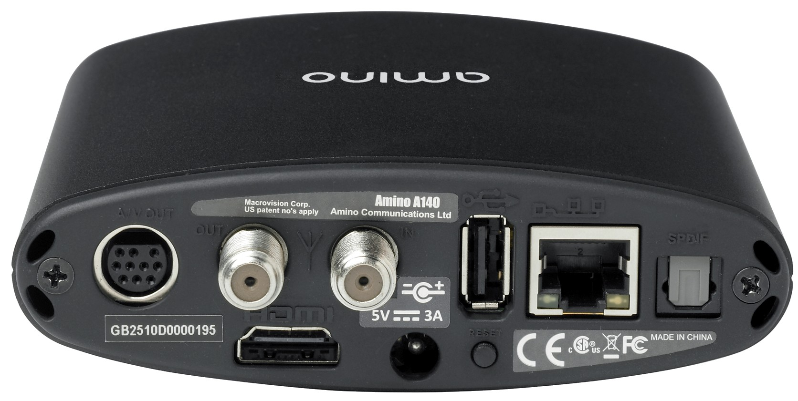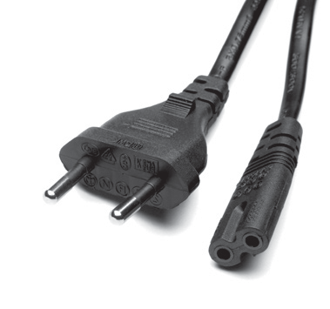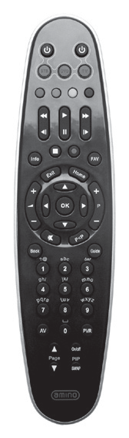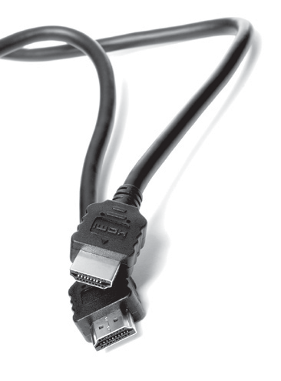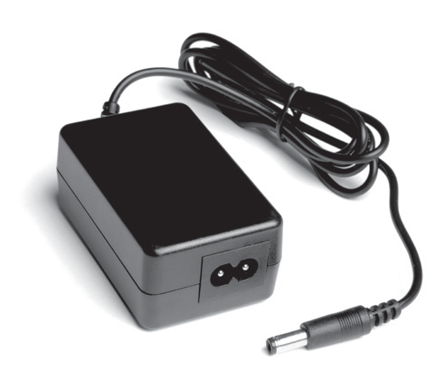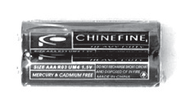
REAR PANEL
2
6
1

2

3
4
5
1
Analogue AV 6
output 7
RF Modulator
output 8
HDMI output 9
RF antenna input DC power input
3 4 5 9 7
8
USB
Ethernet
Optical S/PDIF output
Service button. No function in normal use. Only used under guidance from your service provider
INCLUDED ACCESSORIES *
Power Supply
Batteries
Remote Control
HDMI
Lead
Power Lead
*
shown

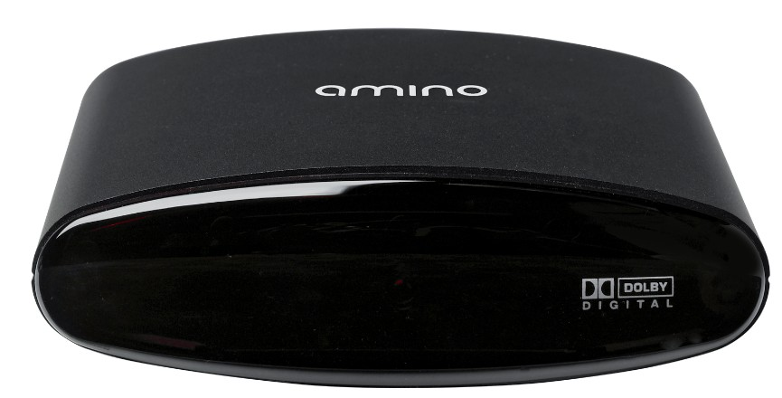
FRONT PANEL
1 Activity LED
Flashing = IR command received

The front window of the Amino A140 is protected with a clear plastic film. This should be removed and disposed of before using the product.
1

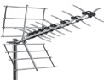
1 CONNECTING YOUR STB TO THE TV
Warning!

(TV,VCR, AV Amplifier, etc) and disconnect from the mains electrical supply.
b
c
a
Choose one connection method in decreasing order of quality (high-low):
- HDMI. Best quality (depends on supplied AV lead).
- Analogue AV. Good quality. Via RCA or SCART (depends on supplied AV lead).
- RF. OK quality. The RF cable must be connected directly to a TV tuner input. This output connector MUST NOT be connected to any cable distribution network, satellite dish or antennae.
A TV terrestrial antenna may only be connected to the RF input to provide loop through functionality to the TV via the STB.
TV
TV
TV

Warning!

(TV,VCR, AV Amplifier, etc) and disconnect from the mains electrical supply.

2 CONNECTING YOUR STB TO AN AV AMPLIFIER (OPTIONAL)
Connect an optical S/PDIF cable to the
S/PDIF optical output of the A140 and the S/PDF optical input of an AV amplifier or home cinema system.

3 CONNECTING YOUR STB TO THE POWER SUPPLY
- Connect the power supply unit to the DC input of the STB.

- Connect the AC cable to the power supply unit.

- Connect the AC plug into the mains supply (supplied AC lead will be regional specific. Please ensure you have the correct AC lead for your region. If unsure please contact your service provider).

SPECIFICATION AMINO A140

Physical Specifications
Weight 262g (0.58lbs)

Dimensions (incl. rear 114mm (4.5”) deep connectors but excl. 114mm (4.5”) wide
base) (approxi) 36.5mm (1.44”) high Operating Temperature 0°C (32°F) to 40°C (104°F)
Storage Humidity 5% ~ 95% RH (non-condensing)

RF Modulator
Output channel VHF channel 3 or 4 (US) UHF channel 21 to 68 (EU)

TV standard PAL/NTSC

RF Output connector 750 F connector

Ethernet Interface
Ethernet connector RJ-45 shielded connector Speed Auto sensing 10/100Mbit/s
Indicators Green LED - link, yellow LED - activity

USB Interface
Type USB 2.0

HDMI
Type HDMI 1.3a (excluding deep colour and DTS audio)

Connector Type A

Digital Audio Interface
Type S/P-DIF optical

Connector TOSLINK connector
AV outputs
The Amino 10-way mini-DIN AV connector will have been configured to output composite, component or S-Video as specified by your service provider at time of manufacturer. An appropriate lead will have been supplied.

Composite Video
10-way mini Din to RCA- yellow
Output 1Vp-p

S-Video Type Y/C (separate luminance and chrominance)

Connector 4-pin Mini-DIN Output 1Vp-p

Component Video
Type RGB or YPrPb

Connectors 10-way mini Din to RCA green=Y, red=Pr, blue=Pb or green=G, red=R, blue=B
Impedance 750

Output 0.7Vpk-pk
(+0.3V synch on Y signal)

Analogue Audio
Audio Connectors 10-way mini Din to RCA, white = left channel, black = right channel

Output 2v RMS nominal

Impedance 10k0

Power Interface
Connector DC10B 2.1mm x 5.5mm
Type DC power socket, centre positive

Input 5V DC, 3A

Power Less than 8W typical usage

External Power Supply Specification
Type Input 100~240V AC, 50~60Hz,0.8A Max
Output 5V DC 3A

Weight (not including 156g (5.5oz) approx mains cable and plug)

Dimensions (approx) 77mm (3.0”) long 33mm (1.3”) high
47mm (1.9”) wide

SOFTWARE LICENSE

Software License Agreement

IMPORTANT - PLEASE READ THIS CAREFULLY:
By using the software in your Amino A140 (“Product”), you (“You”) agree to be bound by the terms of this Software License Agreement (“Agreement”). If you do not agree to be bound by the terms of this Agreement, you must immediately cease all use
of the Product and return the Product and all accessories, in the original packaging to your service provider, or the supplier from which you obtained the Product.

License Grant; Restrictions
Subject to the terms of this agreement, Amino Communications

exclusive, non-transferable license, without the right to sub-license, to use the software included with the Product or subsequently provided to you, and its associated documentation solely for your non-Commercial use and solely in connection with your use of
the Product. You acknowledge and agree that Amino and your service provider may periodically update, modify or enhance the
Product software. You agree that; a) you will not attempt to modify, enhance, disassemble, decompile, reverse engineer or otherwise
attempt to gain access to the source code to the software; and b) you will not attempt to remove or unbundle the software from the Product. Any resale or transfer of the Product by you will be subject to the terms and conditions of this agreement.

Recorded Materials
The Amino A140 is intended for the reception of TV picture and sound signals (“Materials”) for personal use in conformance with applicable laws, license agreements or service agreements under which you have obtained access to such Materials. Any other use is expressly prohibited. It is Your responsibility to comply with, and
you agree to be bound by, all such applicable laws and agreements. Unauthorized recording of copyrighted material, or providing copies of such material to others, may infringe the rights of copyright

Prior permission from the copyright owners may be required for certain public performances and certain commercial uses. You agree to indemnify and hold harmless Amino and its Licensors against any breach by You of applicable copyright restrictions in connection with your use of the Product. Your service provider can advise you on the legitimate use of the Product.
Ownership
Amino and its licensors own and retain all proprietary rights, including all patent, copyright, trade secret, trademark and other intellectual property rights in and to the software and to any enhancements or modifications to the software which may be provided to you. You acknowledge that the license granted under this agreement does not provide you with title or ownership to the software but only to a right of limited use under the terms and conditions of this agreement.

Software Warranties
To the maximum extent permitted by applicable law, Amino makes no representations and disclaims any and all warranties, express or implied with respect to the software, including, without limitation, any implied warranty of merchantability, fitness for purpose, non- infringement of third party rights and those arising from a course of dealing or usage of trade. No representation is made or warranty is given that use of the software will be defect free or error free or uninterrupted, that any defects or errors will be corrected or that the functionality of the software will meet your requirements.

Limitation of Liability
To the maximum extent permitted by applicable law, Amino, its suppliers and licensors will not be liable for loss of profits, business interruption, loss of information or data, or other pecuniary loss, or for any consequential, indirect, incidental, special, punitive or other damages whatsoever arising out of this agreement or the use or inability to use the software, even if Amino or its suppliers or licensors have been advised of the possibility of such damages.

Termination
This agreement and the licenses granted hereunder shall immediately terminate if you fail to comply with the license limitations described in this agreement. No notice will be required

agreement you must return all hardware, software and product documentation and accessories to the service provider, or the supplier from which you obtained the Product.

Export Controls
You acknowledge and agree that none of the software or underlying information or technology may be downloaded or
otherwise exported or re-exported: a) into (or to a national or resident of) Angola, Cuba, Iran, Iraq, Libya, North Korea, Sudan, Syria, or any other country to which the US has embargoed goods; or any one on the US Treasury Department’s list of Specially Designated Nationals or the US Commerce Department’s Table of Denial Orders. By using the software, you represent and warrant that you are not a resident or national of any such country or on any such list.

US Government Users
This software is a commercial product and is provided with restricted rights. Use, reproduction, release, modification or disclosure of the software or any part thereof including technical data is restricted in accordance with Federal Acquisition Regulation (FAR) 21.212 for civilian agencies and Defense Federal Acquisition (DFARS) 227.7202 for military agencies.

Law
If you acquired this Product in the United States, this agreement shall, in all respects, be governed by the laws of the State of
Georgia without reference to its principles or conflicts of laws. You
hereby agree that all disputes arising out of this agreement shall be subject to the exclusive jurisdiction and of and venue in the federal and state courts within Atlanta, Georgia, and you hereby consent to the personal and exclusive jurisdiction and venue of these courts. If you acquired this product in the United Kingdom, the laws of England shall apply, and you hereby consent to the exclusive jurisdiction and venue of these courts. If you acquired this product elsewhere, then local law may apply.

Miscellaneous
If any of the provisions of this agreement are held to be invalid under any applicable statute or rule of law, they are, to that extent, deemed omitted. Any delay by Amino in exercising any of its rights shall not constitute a waiver of any such right. This agreement constitutes the complete and exclusive agreement between you and Amino with respect of the subject matter hereof and supersedes all prior oral or written understandings, communications or agreements. This agreement may not be modified except in writing by a duly authorized representative of

on interpretation of this Agreement.

COPYRIGHT NOTICE

© Amino Communications Ltd. All rights reserved. Printed in China. Amino, AmiNET and Amino A140 are trademarks of Amino Communications Ltd. All other product or brand names as they appear are trademarks or registered trademarks of their respective holders. This document contains proprietary information of Amino Communications Ltd (“Amino”) No part of this document may be copied, reproduced, transmitted, distributed, transcribed, stored in a retrieval system, modified or translated into any other language or computer language, or sublicensed in any form or by any means - electronic, mechanical, magnetic, optical, chemical, manual or otherwise - without the prior written consent of Amino.

Disclaimer
Amino shall not be liable for any errors contained herein nor for any damages arising out of or related to this document or the information contained within it, even if the Company has been advised of the possibility of such damages. This document is intended for informational and instructional purposes only. The Company reserves the right to make changes to the specifications and other information contained in this document without prior
notification.
Warranty

provider, or the supplier from which you obtained it. In the case of your Amino A140 requiring servicing, please contact your service provider directly.

Trademarks
Dolby and the double-D symbol are trademarks of Dolby Laboratories.

Manufactured under license from Dolby Laboratories. HDMI is the trademark of HDMI Licensing, LLC.
Macrovision U.S. Patent numbers 4,631,603, 4,577,216 and 4,819,098 licensed for limited payper- view uses only.
This product incorporates copyright protection technology that is protected by U.S. patents and other intellectual property rights. Use of this copyright protection technology must be authorized by Macrovision and is intended for

home and other limited pay-per-view uses only unless otherwise authorized by Macrovision. Reverse engineering or disassembly is prohibited.

“Contains iType™ from Monotype Imaging, Inc. “Monotype”, “iType” and “Albany,” are trademarks of Monotype Corporation registered in the U.S. Patent and

Opera®” is a trademark of Opera Software AS.

Approvals
FCC Registration and Requirements
The following paragraphs set out requirements and information required by FCC rules:

FCC Rules, Part 15
This equipment has been tested and found to comply with the limits for a class B digital device, pursuant to Part 15 of the FCC Rules. These limits are designed to provide reasonable protection against harmful interference in a residential installation. This equipment generates, uses and can radiate radio-frequency energy and, if not installed and used in accordance with
the instructions, may cause harmful interference to radio communications. However, there is no guarantee that interference will not occur in a particular installation. If this equipment does cause harmful interference to radio of television, which can be

encouraged to try to correct the interference by one or more of the following measures:

- Reorient or relocate the receiving antenna

- Increase the separation between the equipment and the receiver

- Connect the equipment into an outlet on a circuit

- Consult the dealer or an experienced radio/TV technician for help

- This device complies with Part 15 of the FCC Rules.

Operation is subject to the following two conditions:

- This device may not cause harmful interference, and

- This device must accept any interference received, including interference that may cause undesired

Operation
Manufacturer: Amino Communications Ltd
Address: Buckingway Business Park, Anderson Road, Swavesey, Cambridge CB24 4UQ United Kingdom.

Safety
The following paragraphs describe requirements and conformity:

Conformity
EN60950-1-2006
CAN/CSA-C22.2 No 60950-1-03

European Approvals
This product complies with EU Directives:
2006/95/EC (Low voltage Directive) 2004/108/EC (EMC Directive)
2002/95/EC (RoHS Directive)

Product Disposal Information - EU only
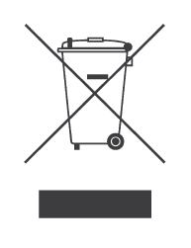AmiNET products are labelled in accordance with the European Directive 2002/96/EC concerning Waste Electrical and Electronic Equipment (the WEEE Directive) and therefore should not be disposed of with other household or commercial waste. Product Disposal Instructions for Residential Users Please remove any batteries and dispose of them and the product as per your local authority’s
recycling processes. For further information please contact your local authority or the retailer where the product was purchased. Product Disposal Instructions for Business Users Business users should contact their supplier and check the terms and conditions of the purchase contract and ensure that the product is not mixed with other commercial waste for disposal.

